Connect Synway Wireless Gateway to UC200

There two ways to connect synway wireless gateway to UC200. One is peer to peer mode; another is register mode.

Here we use UC200 (IP:192.168.12.102; Trunk sip port:5080; Extension sip port:5060) and Wireless Gateway (IP:192.168.12.68; Sip port:5060) for example.

# Peer to Peer (Normally applied when UC200 and remote gateway are in the same network)

## UC200 Settings

### Add Trunks

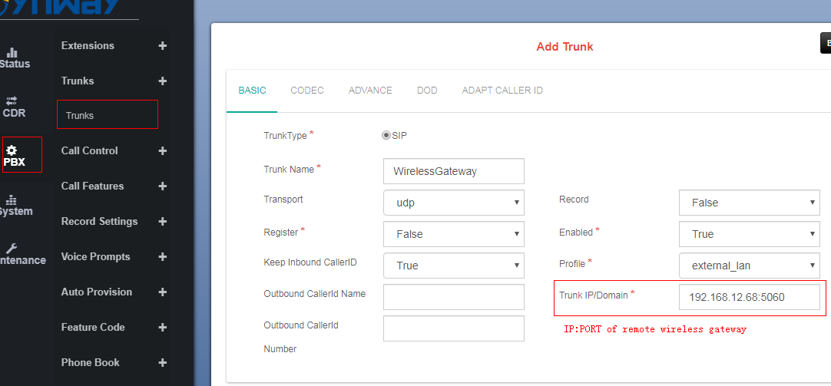

### Add Inbound Route

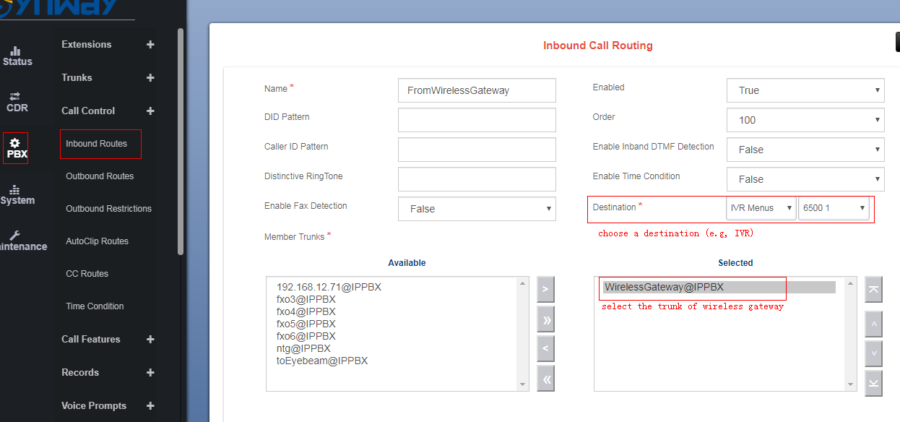

Destination: There are different destinations can be set. Such as DISA, CC, Conference Room etc. These destinations should be preset in Call Features.

### Add outbound route

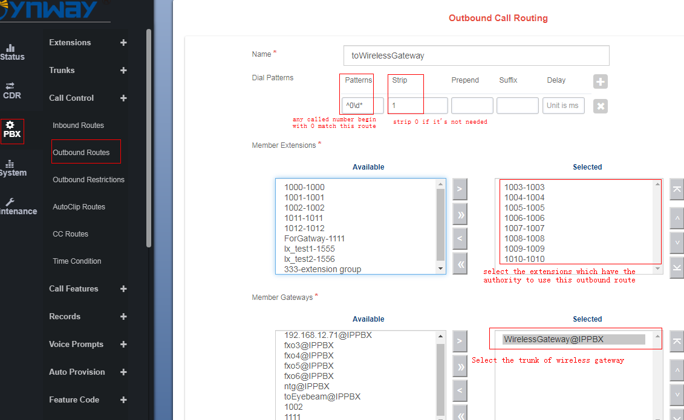

DID Patterns: Any calleeID matches this pattern matches this outbound route. DID patterns have regular expressions. You can check the tips on the webpage for further detail rules. Here we use ^0\d* for example.

Strip: Usually the calleeID prefix is not needed when gateway making a phone call, so you could strip 1 digit here to delete the prefix.

## Wireless Gateway settings

### Port Editing

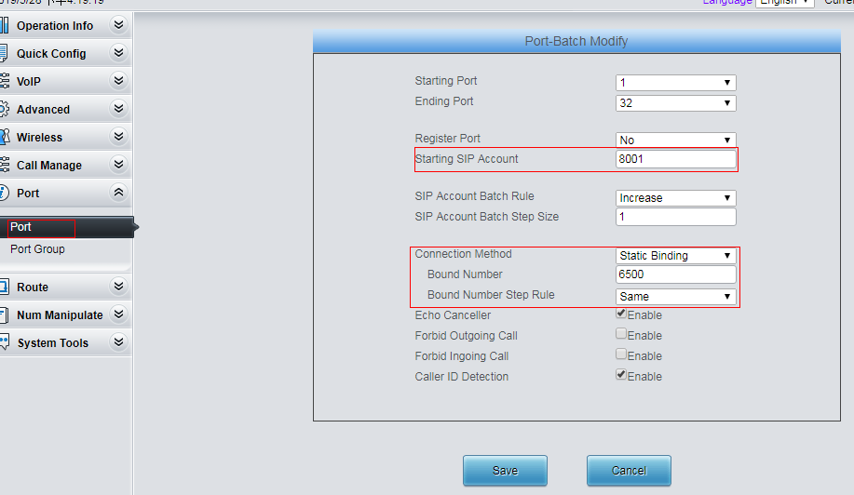

Connection Method: Connection method should set as Static Binding. Bound number will be the calleeid, if you make a tel>ip phone call. Here we set 6500, which is the UC200’s IVR number.

### Add Port Group

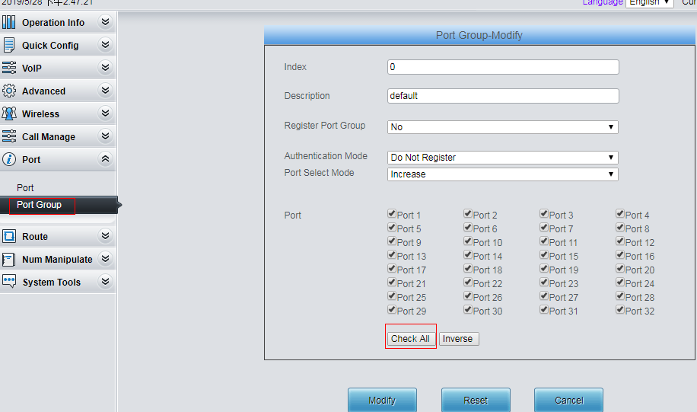

Port Group: Select all the ports which you want to use.

### Add Routes

1. IP>TEL

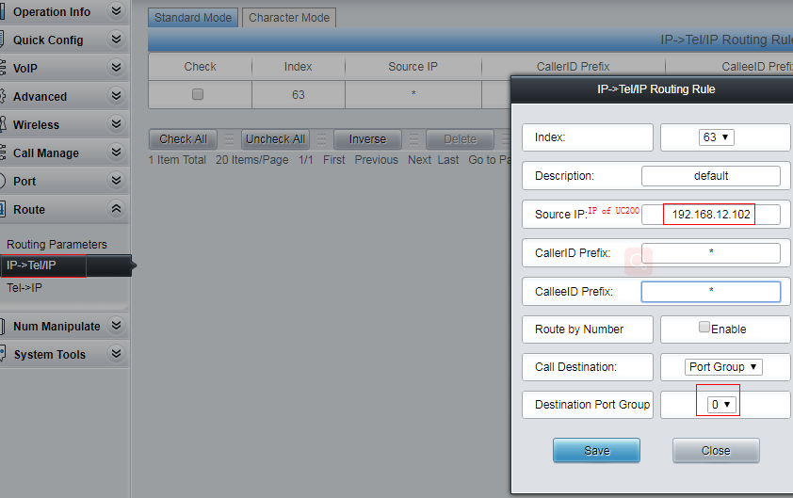

1. TEL>IP

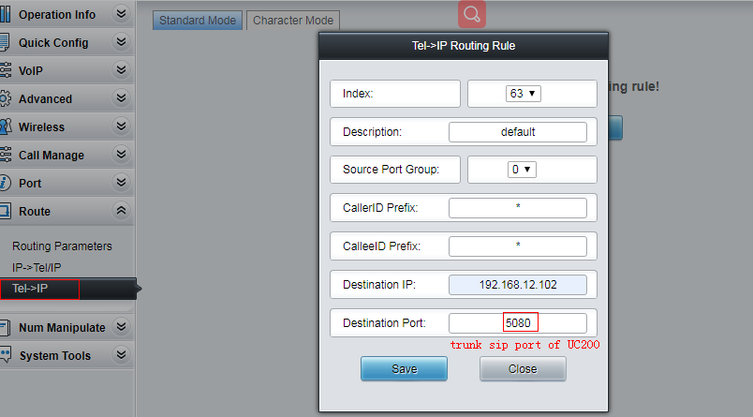

Destination Port: The trunk sip port is different with extensions sip port. The default trunk sip port of UC200 is 5080. You could change it in PBX>SIP Settings.

# Register Gateway to UC200(Normally applied when UC is in local network while remote PBX is on public, registration would be applied for NAT traversal mostly)

## UC200settings

### Create a Extension Trunk

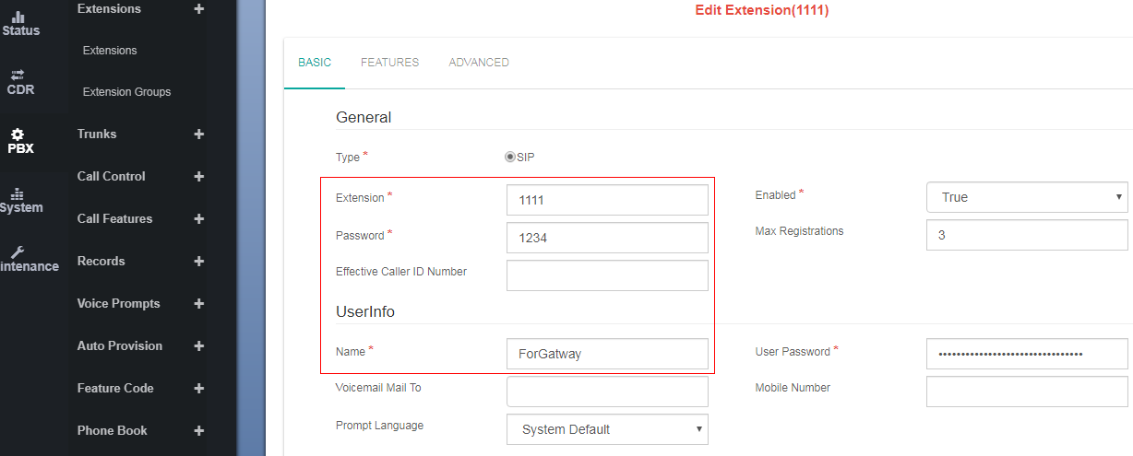

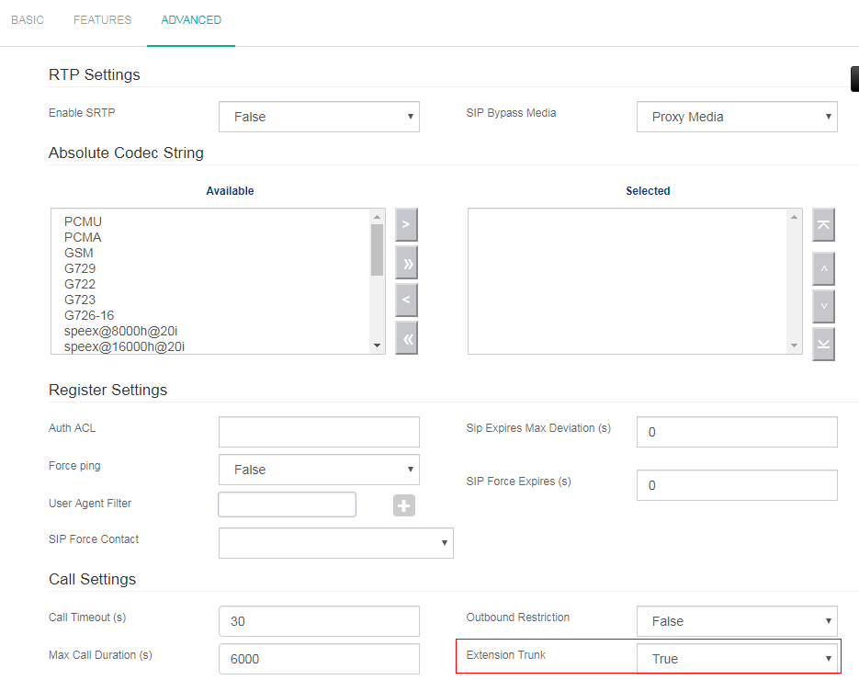

Extension Trunk: This feature must be enabled.

### Inbound Routes

There is no need to add inbound routes in this mode.

### Outbound Routes

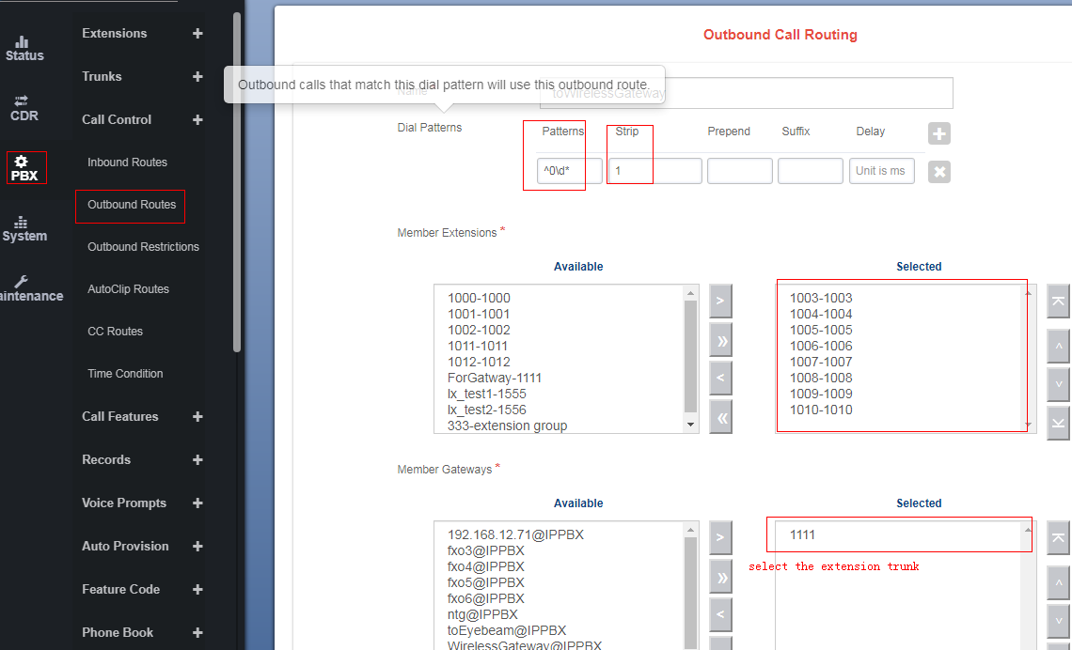

Member Gateways: Select the extension trunk.

DID Patterns: Any calleeID matches this pattern matches this outbound route. DID patterns have regular expressions. You can check the tips on the webpage for further detail rules. Here we use ^0\d* for example.

Strip: Usually the calleeID prefix is not needed when gateway making a phone call, so you could strip 1 digit here to delete the prefix.

## Wireless Gateway Settings

### SIP settings

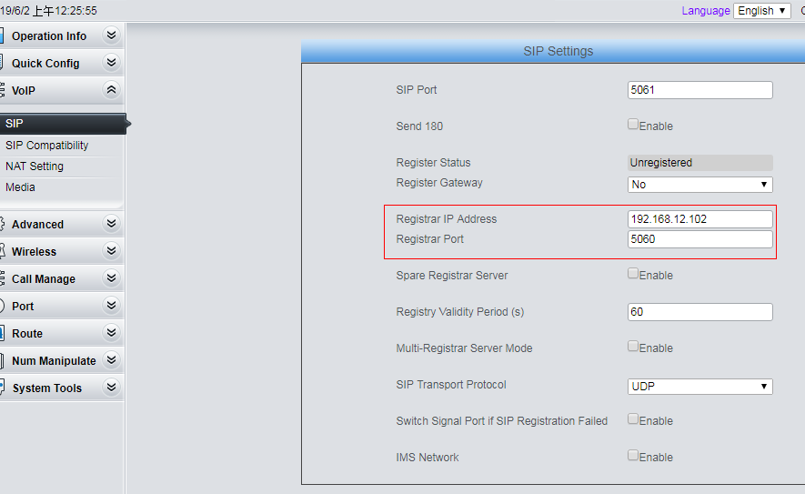

Registrar IP Address: The IP address of UC200.

Registrar Port: The extensions sip port. The default extensions sip port of UC200 is 5060. You could change it in PBX>SIP Settings.

### Port Editing



Connection Method: Connection method should set as Static Binding.

Bound number: Bound number will be the calleeid, if you make a tel>ip phone call. Here we

set 6500, which is the UC200’s IVR number.

IVR number can be changed in PBX>Call Feature>IVR.

### Port group

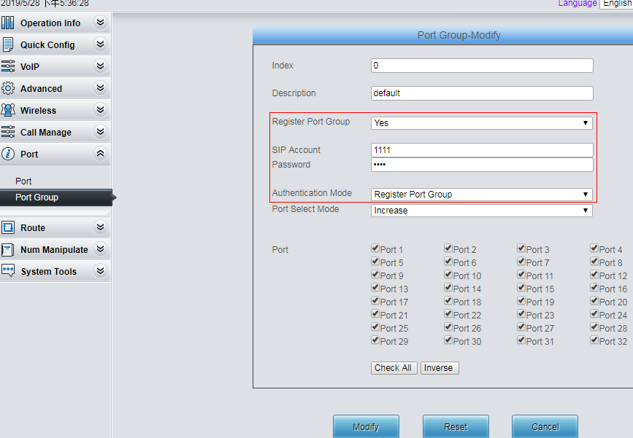

Use the UC200’s extension trunk account to register this port group.

Authentication Mode: Choose Register Port Group.

### Add Routes

1. IP>TEL



1. TEL>IP

Since it’s register mode, there is not need to add tel>ip route.