**I have VoIP gateway with older VoIP card and want to replace it new thin VoIP card.**

**1. Installation**  
Thin VoIP card is compatible with all VoIP gateways (StarGate, BlueStar) and BlueTower with new chassis. For installation of thin VoIP card remove VoIP card allready installed in gateway and insert thin VoIP card to this empty position.

For correct functionality of thin VoIP card you have to use firmware version 2.30.01 or higher and firmware for VoIP card. Firmware version 2.30.01 has to be used withboot 2.52 or higher.

All firmware files can be uploaded using configuration tool. Version of configuration tool has to be 1.1g or higher.

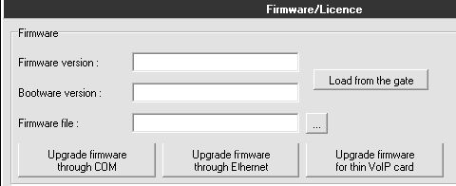

Firmware for gateway can be uploaded via COM or ethernet connection. Firmware files has suffix hex (for example P2005-V-02.30.01.hex).  
Firmware for VoIP card is uploaded via ethernet connection. Firmware files has suffix out (for example SECUREDM642.out).

**For succesfull VoIP card firmware upload MAC address for VoIP card has to be set on CPU.**

You can check it by AT command ATI4  
ati4  
SNumber: M112-0812345678  
MacAddr: 00-20-C5-D2-AB-C2  
**DspAddr: 00-00-00-00-00-00**  
Enabled: DSS1 SIP TUN  
Limited: 2335 hours (no limit)  
Network: (all)

If MAC address is 00-00-00-00-00-00 please contact support@2n.cz and we will provide you with MAC address. MAC address can be set by AT command AT!V5SE=macaddr. MAC address has to be written together without dashes (for example AT!V5SE=0020C5D2ABC2)

**2. Configuration**  
Configuration of all VoIP card setting is done in Gateway configuration > VoIP parameters.

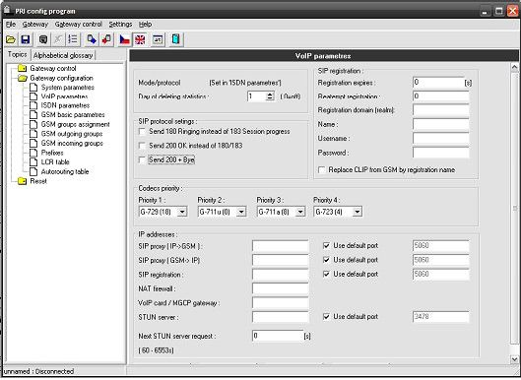

**VoIP card/MGCP gateway** - IP address of VoIP card. Its automatically set to VoIP card.

**Codec priority** - set priority of codec usage. Supported codecs are G.711a, G.711u, G.723 and G.729