2N Stargate ürünü ile ilgili teknik spec bilgileri

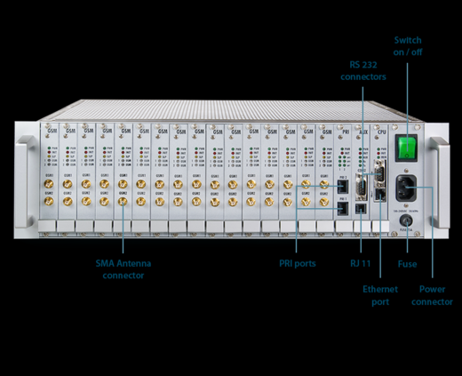

VoIP

Voice signalling

SIP

DTMF sending

RFC2833

No. of voice channels

30

Codecs

G.711 PCM A-law/u-law (selectable)

G.729 Annex A CS-ACELP at kbps

G.723.1 MP-MLQ/ACELP at 6.3/5.3 kbps (optional)

Echo Cancelation

G.168-2000; max. echo length 25 ms (15 ms for G.729A)

PRI ISDN

Number of ports

1xNT and 1xTE

PRI ISDN details

Signalling EDSS1 (Q.931)

Frame type

E1

GSM/UMTS interface

Number of channels

2-32 (step by 2)

Network bands

GSM 850/900/1800/1900 MHz

GSM Modules

Cinterion MC55i

Communication

Protocols

TCP, UDP, IP, RTP, TELNET, HTTP, FTP

Connector type

LAN 10Base-T, LAN 100Base-T, RJ45,

2x RS232 - AT interface

Administration method

AT command

Administration SW

Web interface

Power source

Power supply type

100-240V, 50-69Hz or 36-70V DC

Power input

Max. 230 VA

Operation temperature

0-40 °C

Operation humidity

10-95% (non condensing)

Dimensions

482x133x360mm (84HPx3Ux360mm)

Recommended

Air conditioning

Line interactive UPS