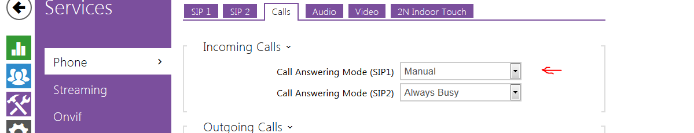

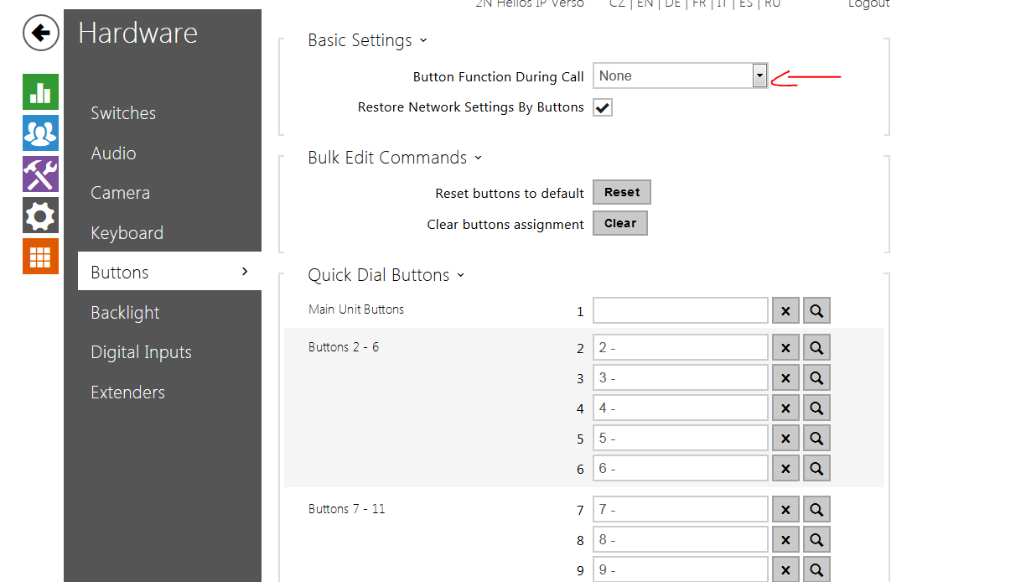

Event.KeyPressed Key=%1

Action.BeginCall Event=1; Condition=3; user=3

Condition.CallState state=idle

Action.AnswerCall Event=1

Action.EndCall Event=1; Condition=6

Condition.CallState State=connected

Condition.CallState State=ringing; Direction=outgoing

Action.EndCall Event=1; Condition=7

