1. [FAQ](https://2nwiki.2n.cz/display/FAQ?src=breadcrumbs-homepage)
2. **…**

1. [2N® Mobile Video EN](https://2nwiki.2n.cz/pages/viewpage.action?pageId=60261019&src=breadcrumbs-parent)

[How to add 2N® Helios IP intercom - I don't have a card with Security Code](https://2nwiki.2n.cz/pages/viewpage.action?pageId=60261026)

[Skip to end of metadata](https://2nwiki.2n.cz/pages/viewpage.action;jsessionid=42B93DF39B3DFAA1C821BF34920D4D12?pageId=60261026#page-metadata-end)

* [https://2nwiki.2n.cz/download/resources/com.atlassian.confluence.plugins.confluence-page-banner:page-banner-resources/images/grey_attach.png](https://2nwiki.2n.cz/pages/viewpageattachments.action?pageId=60261026&metadataLink=true)

[Go to start of metadata](https://2nwiki.2n.cz/pages/viewpage.action;jsessionid=42B93DF39B3DFAA1C821BF34920D4D12?pageId=60261026#page-metadata-start)

**2N® Mobile Video** is service under **My2N** account which allows you to make calls from **2N® Helios IP Intercoms** to mobile devices over internet.

Prerequisites:

**2N® Helios IP intercom**  **firmware version 2.17 or newer.**

**2N® Helios IP intercom**  **needs to be connected to internet.**

Icon

No extra license in **2N® Helios IP intercom** is required for connection to **My2N.**

Step by step guide:

1. Login to [https://my2n.com](https://my2n.com/)

Icon

For detailed information how to access **My2N** and sign up, please read following article:[2N® Mobile Video Setup - registration and general settings](https://2nwiki.2n.cz/pages/viewpage.action?pageId=60261023)

1. Check for  My2N ID (**please use your own My2N** **ID**) by clicking on button **Where to call from?**.

 Please see pictures below for information where to locate My2N ID:

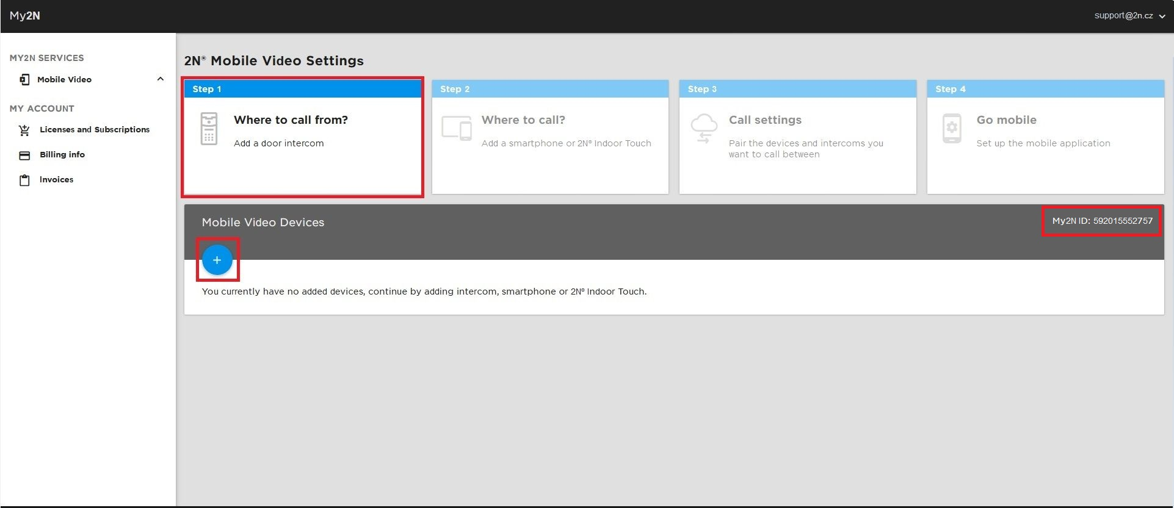

New dialog window will appear showing also **My2N ID**:

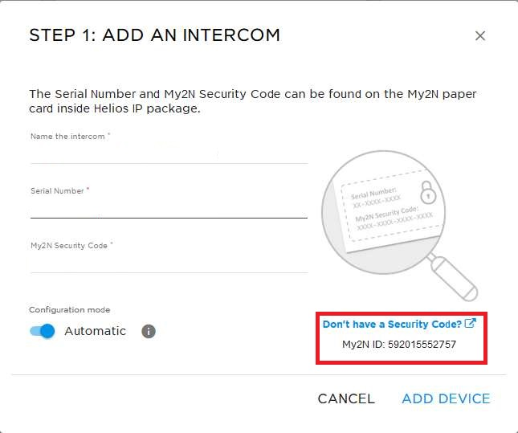

After you acquire **My2N ID**, click on **CANCEL**.

**Note**

Icon

Please note you can add same device (same serial number) only to one **My2N** account.

In case you already same intercom to different **My2N** account, you need to remove it first.

1. Open **2N® Helios IP intercom** using your web browser and navigate to section **My2N** on dashboard (main screen right after you login to device)  
   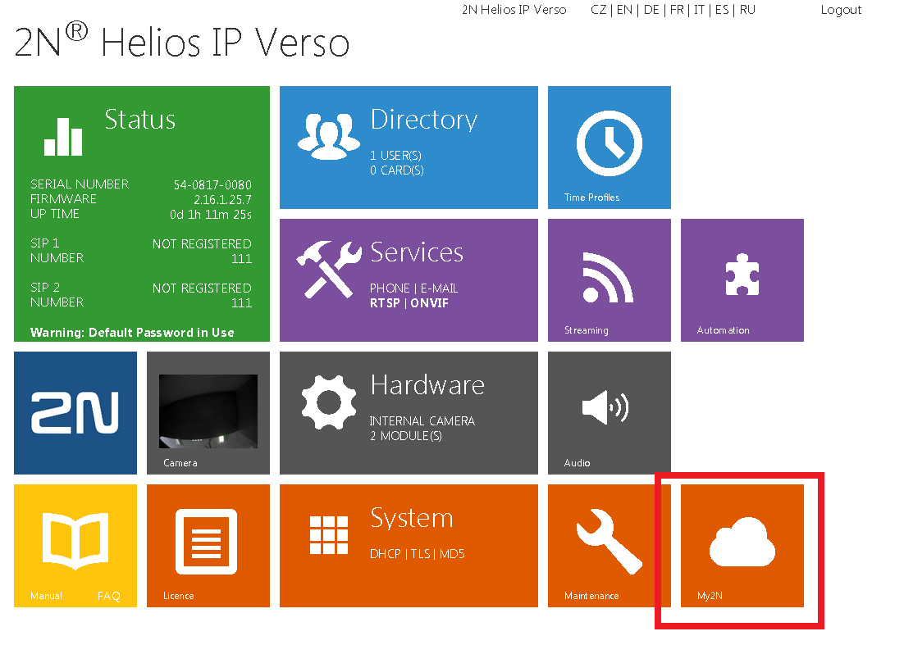

Icon

If you need to identify IP address of your intercom, please check following article for detailed information how to obtain it:

[IP address - How to get IP address of 2N® Helios IP](https://faq.2n.cz/pages/viewpage.action?pageId=7353094)

1. Fill in parameter for My2N Settings - My2n ID **with your My2N ID**.  
     
   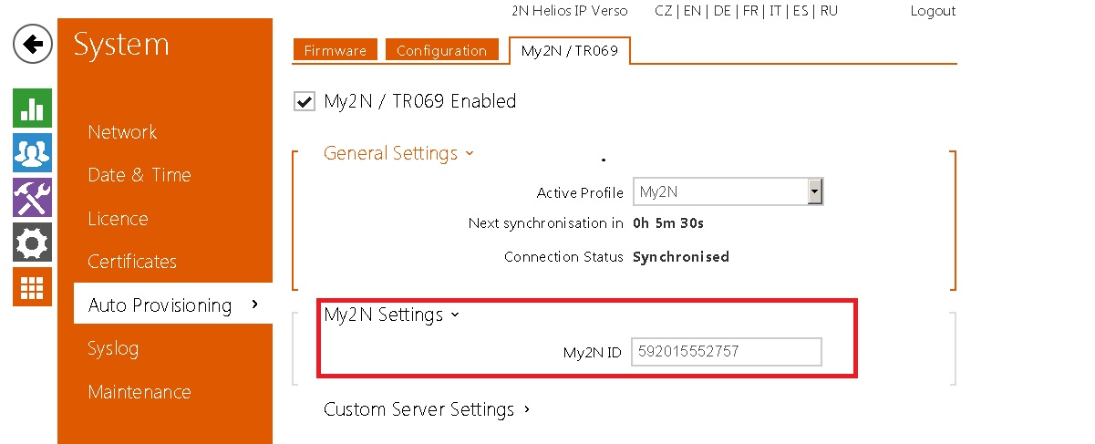

1. After you save new settings, intercom will be synchronized with your **My2N** account.  
     
   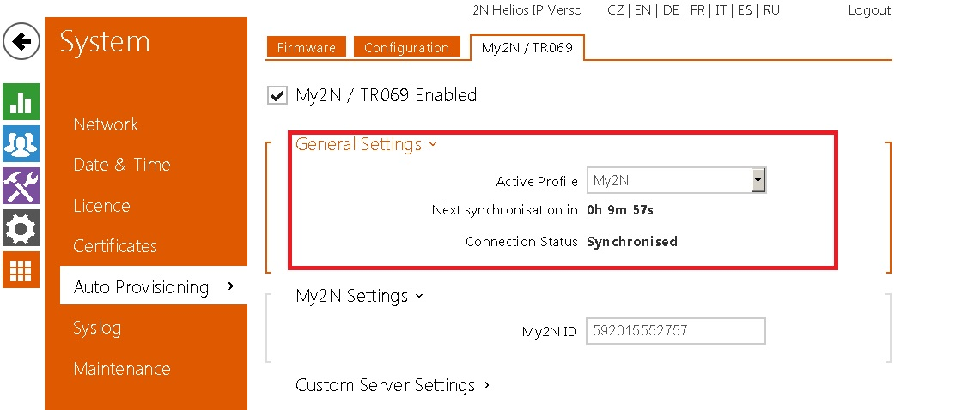
2. Switch back to **My2N** and you will see intercom you just configured waiting for approval in section **Mobile Video** and its subsection **Settings**  
     
   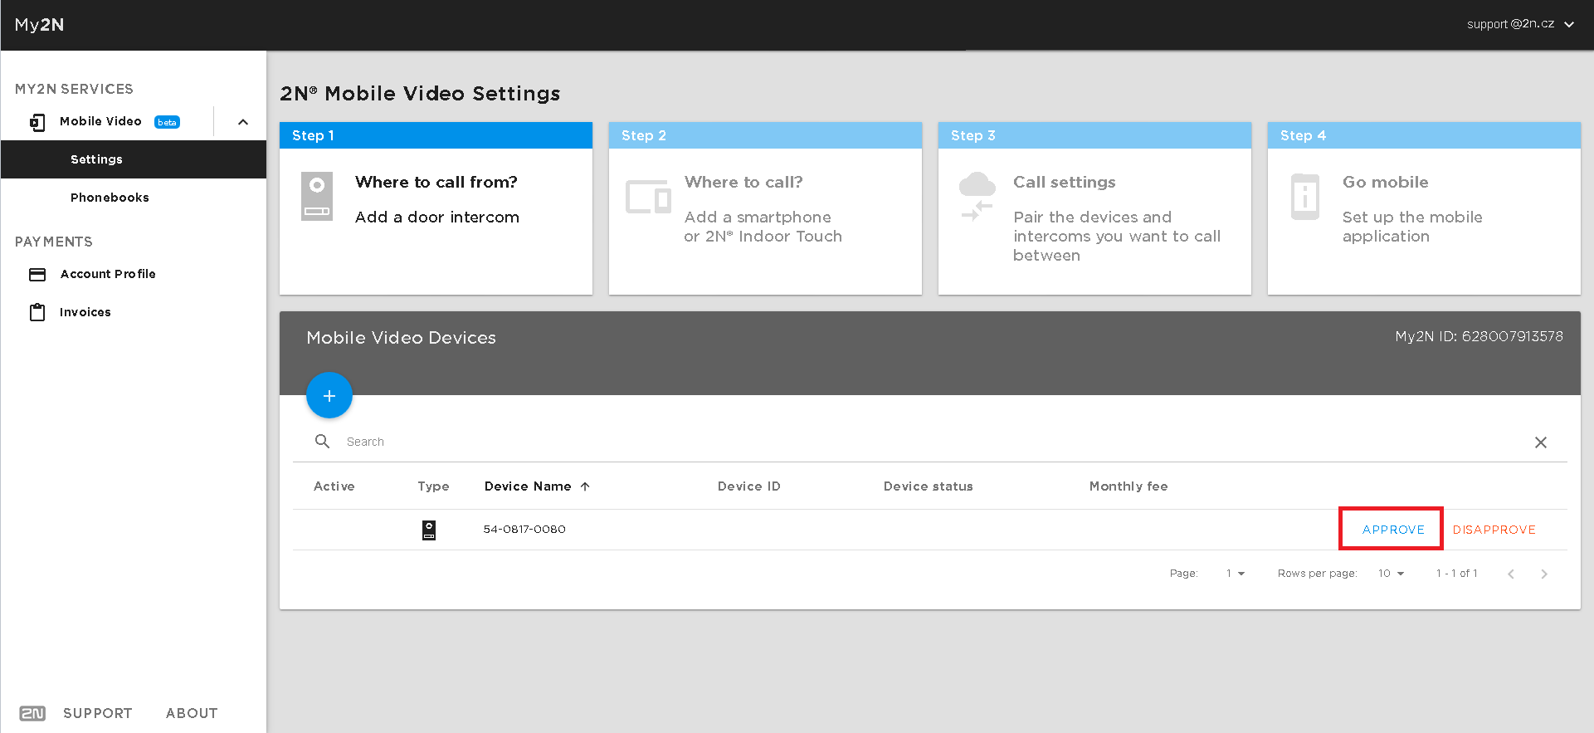
3. You need to approve your added **2N® Helios IP intercom** device.  
     
   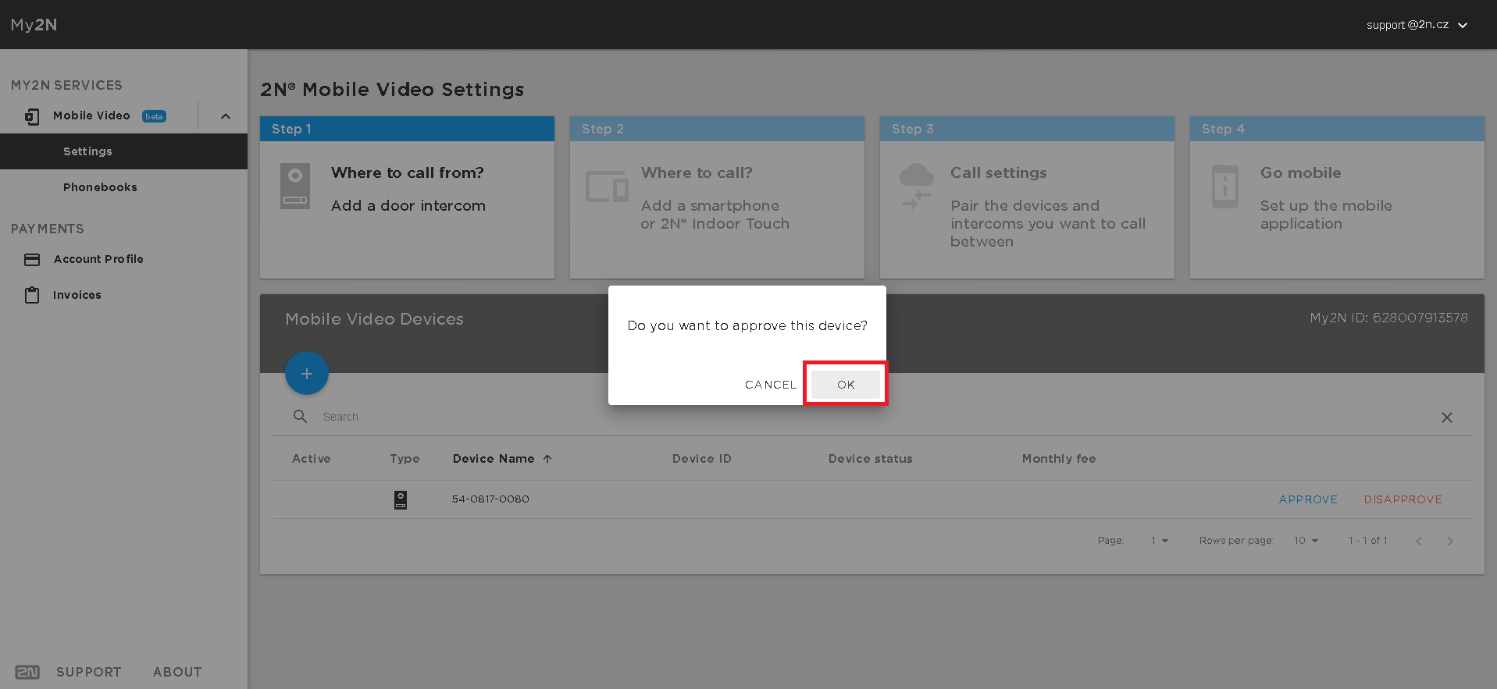
4. New dialog will open where you will assign device to **2N® Mobile Video** service.

If you choose to have intercom connected in **Automatic Mode** (set by default), device will be configured automatically with **My2N**.

Whole process then takes several minutes to complete.

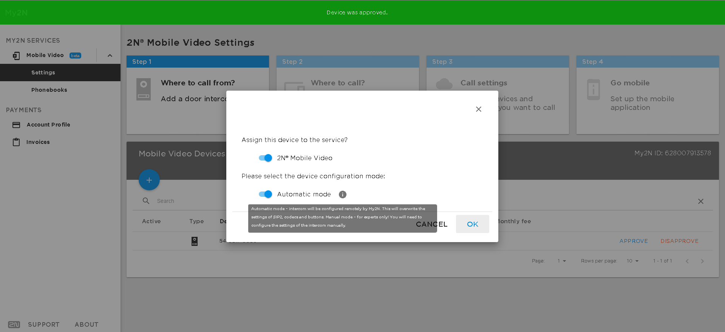

Icon

If you do not want to use **Automatic mode** for intercom's configuration with **My2N**, please visit following article:

[I don't want to use an automatic configuration via TR069 - Manual configuration of the Helios IP intercom](https://2nwiki.2n.cz/display/FAQ/I+don%27t+want+to+use+an+automatic+configuration+via+TR069+-+Manual+configuration+of+the+Helios+IP+intercom)

Icon

Please note that if you want to have device configured automatically for **My2N** using **Automatic mode**, device should not be connected to **2N® Access Commander**, otherwise configuration from **My2N** will not be possible.

1. Now you have succesfully added **2N® Helios IP intercom** to your **My2N** account.

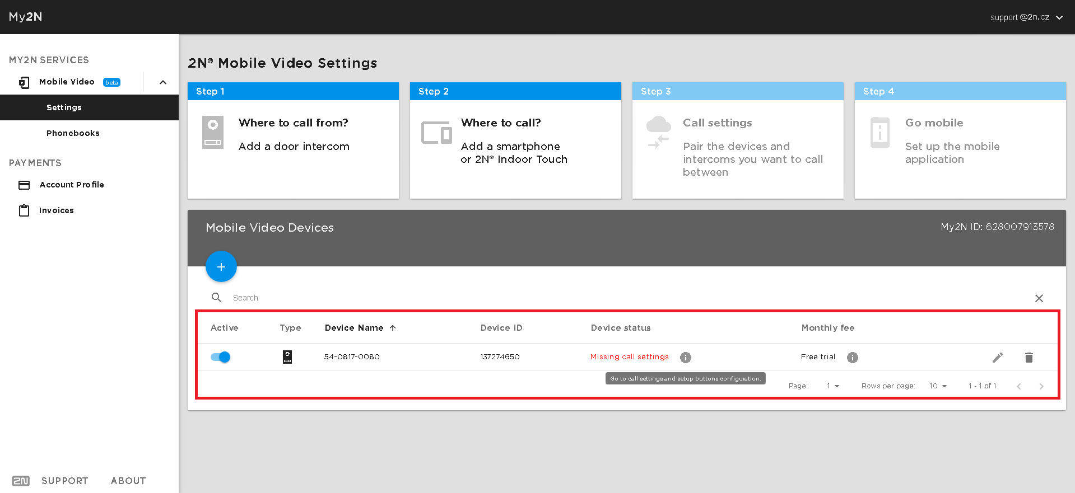

What to do next:

Once intercom is in state Missing call settings , please see which steps needs to be taken next:

**- Please add to your My2N account mobile device you wish to call from intercom to.**

Icon

You can add smartphone or tablet, 2N® Indoor Touch or 3rd party devices/ applications.

For detailed information how to add them, please visit following articles:

[How to add smartphone or tablet to My2N account](https://2nwiki.2n.cz/display/FAQ/How+to+add+smartphone+or+tablet+to+My2N+account)

[How to add 2N® Indoor Touch to My2N account](https://2nwiki.2n.cz/pages/viewpage.action?pageId=60915985)

[How to add SIP 3rd party device or SIP 3rd party application to My2N account](https://2nwiki.2n.cz/display/FAQ/How+to+add+SIP+3rd+party+device+or+SIP+3rd+party+application+to+My2N+account)

**- Please set intercom's buttons in order to point them to mobile device you wish to call from intercom to.**

Icon

In order to make calls from intercom to mobile devices over **My2N**, buttons on intercom needs to be configured to call correct mobile devices.

For detailed information how to set buttons, please visit following article:

[How to configure call settings for 2N® Helios IP Intercom](https://2nwiki.2n.cz/pages/viewpage.action?pageId=60915990)